

**Laboratory Technical Bulletin**

**Date:** January 14, 2020

**Effective Date:** Transition to bottles with new labels upon depletion of existing supply

**Title:** Blood Culture Bottle Labels

**Test:** Blood Culture

**Explanation of change:**

Aerobic (green) and anaerobic (orange) blood culture bottles have new labels with pre-printed fill lines. Bottles will no longer have hand marked fill lines added.

Due to the low sample volume, pediatric (yellow) bottles will still be hand marked.

|  |  |
| --- | --- |
| **Old Label**  All bottles have hand marked fill lines. | **New Label**  Green & orange bottles have pre-printed fill lines. Yellow bottles have hand marked fill line (no change). |
| cid:563ad041-75cf-45db-915d-7e9eaeb852bf@CAYUGAMED.org |  |

Place the Meditech label on the bottles vertically, with the barcode facing the same direction as the pre-printed bottle barcodes. Do NOT cover up or place any labels on the fill window, lot information or 2D barcode.

Bottles MUST be labeled correctly, in order for the analyzer to work properly.

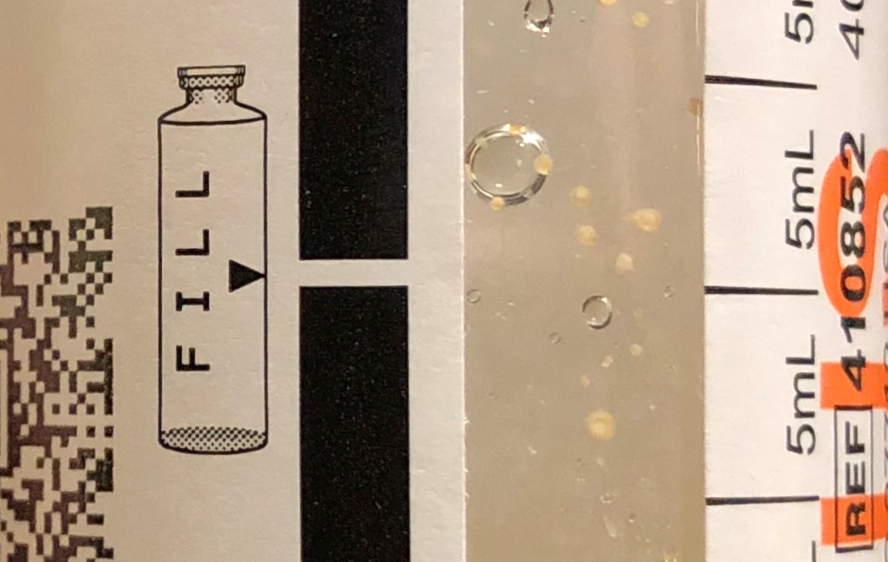 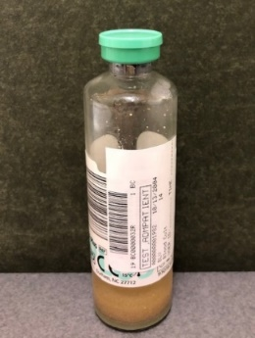

Correct label placement

New fill line marking

Please contact the Laboratory at (607)274-4474 with any questions.

___________________________________________________Date_____________________________

Dr. Daniel Sudilovsky, Laboratory Medical Director

___________________________________________________Date _____________________________

Toni Burger, Laboratory Administrative Director